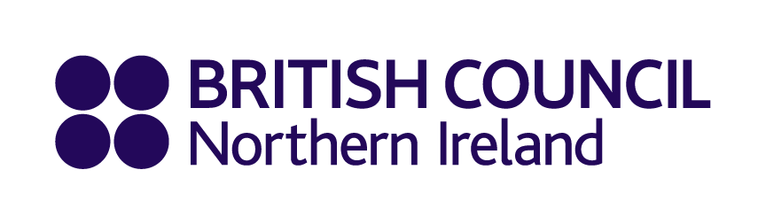

British Council Northern Ireland
Equality Monitoring Form

As an Equal Opportunities Employer, British Council Northern Ireland aims to provide equality of opportunity to all persons regardless of their religious belief; political opinion; gender; race/ethnicity; age; sexual orientation; marital status; or whether or not they have a disability; or whether or not they have dependants.

We do not discriminate against our beneficiaries, job applicants or employees on any of the grounds listed above.

To demonstrate our commitment to promoting equality we would be very grateful if you would complete the questionnaire below so that we can:

a) measure the effectiveness of our equality policies
b) develop affirmative or positive action policies
c) comply with our duties under Section 75 of the Northern Ireland Act (1998)

Your responses will be treated with the strictest confidence and in line with data protection requirements. To protect your privacy, you should not write your name on the questionnaire. The form will carry a unique identification number and only our Equality Manager will be able to match this to your name.

Completed forms should be emailed to sarah.brisbane@britishcouncil.org or sent by post to:

Sarah Brisbane
Equality Manager
British Council Northern Ireland
The Boat 7th Floor
49 Queen’s Square
Belfast
BT1 3FG

If you have any questions please contact Sarah on 02890 192201 or sarah.brisbane@britishcouncil.org

Position applied for: British Council Northern Ireland Advisory Committee Chair

Gender:
Male:

Female:

Prefer not to say:

Religious Denomination:
No religion or faith Jewish
Buddhist Muslim
Christian Sikh
Hindu Prefer not to say

Other (please indicate)

Age:
16-25 46-55
26-35 56-65
36-45 66+

Prefer not to say

Disability:
Under the Disability Discrimination Act 1995 you are deemed to be a ‘disabled person’ if you have a physical or mental impairment which has a substantial and long term adverse effect on his/her ability to carry out normal day to day activities.

Do you consider that you meet this definition of disability?

Yes: No: Prefer not to say:

Racial/Ethnic Group:
Please indicate which of the following applies to you:

White Chinese

Irish Traveller Indian

Pakistani Bangladeshi

Black Caribbean Black African

Black Other Prefer not to say

Mixed ethnic group (please state which): _________________________

Any other ethnic group (please state which): _________________________

Sexual Orientation:
Please indicate your sexual orientation by ticking the appropriate box below:

I am heterosexual: I am bisexual:

I am gay or lesbian: Prefer not to say:

Marital Status / Civil Partnership Status:
Are you married or in a civil partnership?

Yes: No: Prefer not to say:

Dependants / Caring Responsibilities:
Do you have dependants, or caring responsibilities for family members or other persons (by dependant we mean someone who relies on you for day-to-day care)?

Yes: No: Prefer not to say:

Community Background:
Regardless of whether they actually practice a particular religion, most people in Northern Ireland are perceived to be members of either the Protestant or Roman Catholic communities.

Please indicate the community to which you belong by ticking the appropriate box below:

I am a member of the Protestant community:

I am a member of the Roman Catholic community:

I am not a member of either the Protestant or the
Roman Catholic communities:

Prefer not to say

If you have any data protection queries, please contact the DP Officer at data.protection@britishcouncil.org or c/o British Council, 1 Redman Place, London, E20 1JQ

